# **168 Hours**

**Zoe's avatar**

[Zoe](https://substack.com/@zoeffc)

Aug 30, 2024

Share

Hi guys,

There are 168 hours in a week. If you are sleeping a healthy amount, that’s about 56 hours accounted for. Then you have a 40-hour work week. We are up to 96 hours accounted for. That’s 72 hours left over for you to get a life.

This is a tough love newsletter that is *rife* with assumptions based on my personal experience, but at the end of which I am hoping you take a second to reflect on how you are spending your 168 hours a week.

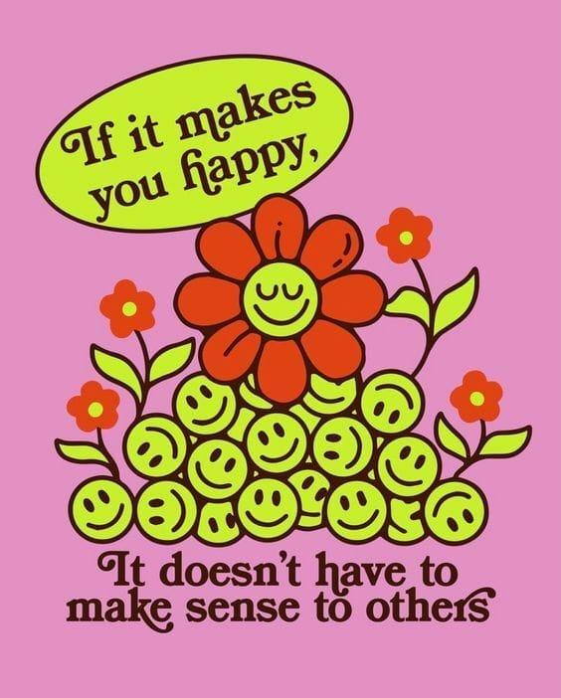

*artist unknown*

First some housekeeping:

📫 If a friend forwarded you this newsletter (then you have some really cool friends). You may want to consider joining us [*here*](https://femme-futures.beehiiv.com/subscribe) for regular updates.

[Subscribe](https://femme-futures.beehiiv.com/subscribe)

🧲 Got some thoughts you want to share? Join us on [*Discord*](https://discord.gg/592wuyvx?utm_source=femme-futures.beehiiv.com&utm_medium=referral&utm_campaign=168-hours) to chat all things newsletter and corporate life.

[Discord](https://discord.gg/N84WxemQ?utm_source=femme-futures.beehiiv.com&utm_medium=referral&utm_campaign=168-hours)

You can find all archived newsletters at the online site, if you ever want to go back or if you just feel like perusing.

[Check out the website](https://femme-futures.beehiiv.com/)

Your (entry-level) job does not require you to work more than 40 hours a week. Unless you are actually saving lives, I don’t want to hear it. You can do it in 40 hours. I do not care if your 8-hour work day starts at 8 am, or noon, or 6:30 pm. Your 8-hour work day could take place in 2 hour chunks with workouts and activities laced through it. For the love of all things good, cap your work week to 40 hours. (Busy weeks get 45 hours if you absolutely cannot do without it.)

There are a few reasons why I am such a hard-ass about this. First, if you are coming out of college, you are coming out of a “job” where you had to set your own hours. You probably worked what felt like 100 hours a week at that, whether in curricular or extra-curricular endeavors. That was your entire life. It is hard to switch out of that mindset. It is hard to figure out what you actually like doing and what is worth your time. It is hard, but it is worth it. It will make you friends, it will save your mental health, and it will increase your resilience.

Second, you are setting unreasonable expectations for yourself, your team, and the people in your life. When you start a job or enter a team, everyone is doing a temperature check on you. What is your work ethic? How competent are you? How long does it take you to do something? You need to transition your brain from the sprint mode that was honed through 4 years of college with 16-week semesters, to the marathon that is the rest of your life.

Now, I am not saying to half-ass your job. I want you to be proud of what you produce and how you produce it. It is just essential that you keep an eye on long-term sustainability. You will have periods of your life where everything is hard and doing what used to feel like the easiest thing in the world will suddenly feel like swimming through molasses. I am saying don’t give 120% because that’s not sustainable.

A corporate mindset tip I came across this year is to list all the things you absolutely need to do and then know that only the top three get to be done perfectly. The rest simply needs to get done. As a perfectionist — this is feels impossible. But you have to try. Save your energy for the things that most need it. Sometimes, done is good enough.

Third, if you put more than 40 (okay 45, but don’t push it) hours into your job, you are losing out on some of those 72 hours a week to get a life. Getting a life is the hard part. This part requires self-reflection and deep self-knowledge. You are in your 20s and honestly, there is no correct path. Learn what you like, what feels good in your body, and what lights you up.

I am a girl of my routines and saying “yes” to invitations and activities does not come easily to me. The first half of my 20s has been an exercise in overcoming my initial impulse to stay in my routines and with the people that I know and love. I have had to grit my teeth, say “yes”, and just do it. And you know what? Sometimes it sucks. Sometimes I wish I hadn’t gone and done whatever it was. But every once in a while, it leads to a few hours of lightness and joy. It’s a gamble. However, if you keep gambling and paying attention to what you enjoy, you can keep doing those things and just like magic, you are getting a life.

72 hours. That is more time than you spend working. That is more time than you spend sleeping. It is entirely up to you how you spend those hours. You can disregard everything I have just said and work 80-hour weeks. You can spend all of that time with your family. You can learn new skills and read new books. You can take up knitting. You can write a novel. You can pursue an advanced degree.

Just please, make it count for you.

With (tough) love,

Zoe

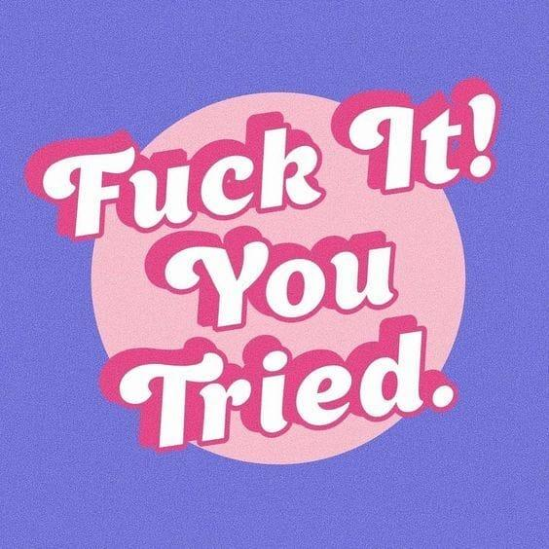

*artist unknown*

**Femme Futures Cooperative Founding Principles**

💚**Mission**: The mission of Femme Futures is to create a community space for young professionals who identify as over-achievers and activists to generate collective success by providing resources and platforms to thrive in challenging workplace environments.

💙**Vision**: To contribute to a world where driven individuals are equipped with the tools, guidance, and connections to overcome systemic barriers, fully utilize their talents, and enact positive change in their organizations and communities.